Predicting Engineering Students’ Interests in Entrepreneurship

# Abstract

# Introduction

# Background

# Methods

# Results

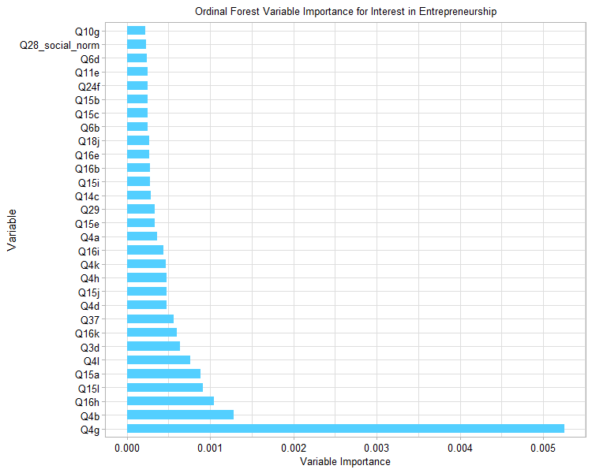

Figure XX. Top 30 Most Predictive Factors by Permutation Importance from Random Forest

Table XX. Survey Items

|  |  |  |
| --- | --- | --- |
| Item Label | Item Text | Item Scale |
| Q4g | **Q4: How important are the following factors to your future career satisfaction?**  Q4g = Inventing/designing things | Anchored 0-4 (Not at all important – Very important) |
| Q4b | Q4b = Becoming well known |  |
| Q16h | **Q16: How interested are you in working on the following solutions in your career?**  Q16h = Building computers capable of emulating human intelligence | Anchored 0-4 (Not very interested – Very interested) |
| Q15l | **Q15: How confident are you in your ability to do the following:**  Q15l = Solve problems in ways that others would consider creative | Anchored 0-4 (Not confident at all – Very confident) |
| Q15a | Q15a = Find sources of inspiration not obviously related to a given problem |  |
| Q4l | Q4l = Solving societal problems |  |
| Q3d | **Q3: Which of the following are you likely to pursue in the next five years? (Mark all that apply)**  Q3d = MBA | Binary 0,1 (No, Yes) |
| Q16k | Q16k = Protecting the nation against cyber-threats |  |

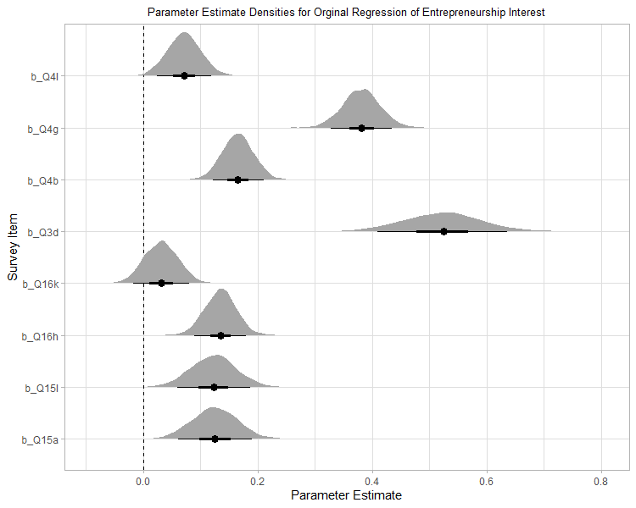

Figure XX. Ordinal regression coefficient estimates for top eight variables identified from ordinal forest in step 1.

Table XX. Ordinal Regression Odds Ratio Estimates

|  |  |  |
| --- | --- | --- |
|  | ordered(Q 2 e) | |
| Predictors | Odds Ratios | CI (95%) |
| Intercept.1. | 1.86 | 1.44 – 2.40 |
| Intercept.2. | 7.14 | 5.55 – 9.17 |
| Intercept.3. | 27.12 | 20.70 – 35.07 |
| Intercept.4. | 144.4 | 107.45 – 193.07 |
| Q 4 b | 1.18 | 1.12 – 1.24 |
| Q 4 g | 1.46 | 1.37 – 1.56 |
| Q 16 h | 1.15 | 1.08 – 1.21 |
| Q 15 l | 1.13 | 1.05 – 1.22 |
| Q 15 a | 1.13 | 1.05 – 1.22 |
| Q 4 l | 1.07 | 1.02 – 1.14 |
| Q 3 d | 1.69 | 1.48 – 1.93 |
| Q 16 k | 1.03 | 0.98 – 1.09 |
| Observations | 3586 |  |
| R2 Bayes | 0.142 |  |

# Discussion

# Conclusion